# Basic command for troubleshooting

**Check any node is under maintenance mode:**

**Execute below command on any CVM**

nutanix@cvm $ ncli host ls | egrep "Maint| Id| Name"|grep true -B2

**Exiting node is under maintenance mode**

CVM id you can find out by executing above command the last two digit of ID in above snapshot it is 16

nutanix@cvm ncli host edit id=**<CVM_ID>** enable-maintenance-mode=false

**Run Nutanix Cluster Check (NCC)**  
Runs the Nutanix Cluster Check (NCC) health script to test for potential issues and cluster health.  This is a great first step when troubleshooting any cluster issues.

nutanix@cvm$ ncc health_checks run_all

Generally, all check should be passed successfully.

**Check local CVM service status**  
Run the following command to check a single CVM’s service status from the CLI. This command shows if all the services on your CVM are UP and running.

nutanix@cvm$ genesis status

The command can also be run in an abbreviated form **gs:**

nutanix@cvm$ gs

Expected output:

nutanix@cvm$ gs

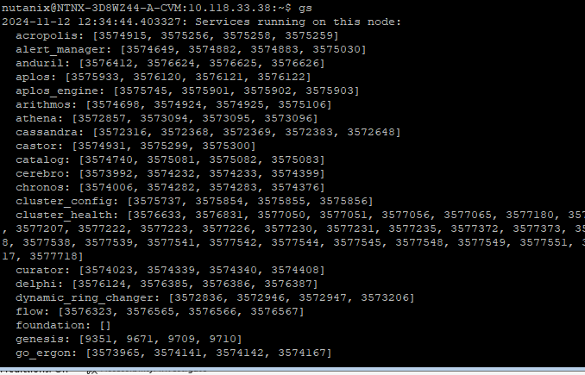

**Note:**The PIDs next to the services will be different when you run this command on your cluster

Using the following command is a simple way to check if any services are crashing on a single node in the cluster.  
  
**Note:** The **watch -d genesis status** command is not a reliable way to verify the stability of cluster_health and xtrim services since they spawn new process ID temporarily for their normal functioning. The new temporary process ID or change in the process ID counted in the "watch -d genesis status" command may give a false impression that the cluster_health and xtrim services are crashing. Rely on the NCC health check report or review the logs of the "cluster_health" and "xtrim" services to ascertain if they are crashing.

nutanix@cvm$ watch -d genesis status

For large clusters, you may have to execute the command one node at a time. Hence it may be a wise decision to correlate with the alert on what CVM so as to check to see which services are reported to be crashing.

**Cluster Commands**

**Check cluster status**  
To check the cluster status of all the CVM's in the cluster from the CLI, run the following command below

 nutanix@cvm$ cluster status

The command cluster status can also be run in its abbreviated form **cs:**

nutanix@cvm$ cs

The following command will give the output for all the nodes in the cluster wherein the services are UP and running.

nutanix@cvm$ cs | grep -v UP

Expected output:

**Start cluster or local service from CLI**  
To start stopped cluster services from the CLI, run the following commands.

Start stopped services or a single service:

nutanix@cvm$ cluster start

**Note**: Stopping some of the services may cause production impact if you are unsure about using these commands, please contact Nutanix Support

**Networking**

**Ping information**  
The following directory consists of files that can help in finding information for pings stats.

nutanix@cvm$ cd /home/nutanix/data/logs/sysstats

Similarly, pinging the nodes can help with basic troubleshooting to check if the nodes (hosts/CVMs) are up and running.

**Software versions**

**Find the NCC version**

nutanix@cvm$ ncc --version

**Find AOS version:**

nutanix@cvm$ allssh "cat /etc/nutanix/release_version"

**Find Foundation version:**

nutanix@cvm$ allssh cat ~/foundation/foundation_version

**Find the host version:**

nutanix@cvm$ hostssh "uname -a"

**Find LCM version**

nutanix@cvm$ allssh "cat ~/cluster/config/lcm/version.txt"

**Note:** All the above information can also be found via the Prism web console. Under the LCM tab or under Settings > Upgrade Software

**Upgrades**  
Upgrades at Nutanix are always designed to be done without downtime for User VMs and their workloads. Refer to [KB-6945](https://portal.nutanix.com/kb/6945) for an introduction to how each type of upgrade works and for some useful best practices for administrators. You will find similar information in the the [Acropolis Upgrade Guide](https://portal.nutanix.com/page/documents/details?targetId=Acropolis-Upgrade-Guide-v5_18:Acropolis-Upgrade-Guide-v5_18) (remember to always choose the guide version that matches the AOS currently running on your cluster).

**Check upgrade status**

nutanix@cvm$ upgrade_status

**Hypervisor upgrade status**  
Check hypervisor upgrade status from the CLI on any CVM

nutanix@cvm$ host_upgrade_status

**LCM upgrade status**

 nutanix@cvm$ lcm_upgrade_status

**Detailed logs** (on every CVM)

nutanix@cvm$ less ~/data/logs/host_upgrade.out

**Logs**

**Find cluster error logs**

Find ERROR logs for the cluster:

nutanix@cvm$ allssh "cat ~/data/logs/<COMPONENT NAME or *>.ERROR"

Example for Stargate:

nutanix@cvm$ allssh "cat ~/data/logs/stargate.ERROR"

**Find cluster fatal logs**  
Find FATAL logs for the cluster:

nutanix@cvm$ allssh "cat ~/data/logs/<COMPONENT NAME or *>.FATAL"

Example for Stargate:

nutanix@cvm$ allssh "cat ~/data/logs/stargate.FATAL"

Similarly, you can also run the following script to list the fatals across all the nodes in the cluster:

nutanix@cvm$ for i in `svmips`; do echo "CVM: $i"; ssh $i "ls -ltr /home/nutanix/data/logs/*.FATAL"; done

**Find cluster ID**  
Find the cluster ID for the current cluster:

nutanix@cvm$ ncli cluster info | grep "Cluster Id"

**Cluster information**  
Find the cluster information for the current cluster from CLI:

nutanix@cvm$ ncli cluster info

**Multi-cluster information**  
To find the multi-cluster (Prism Central) information for the current cluster from CLI use the command below:

nutanix@cvm$ ncli multicluster get-cluster-state

**Node reboots/DIMM/SEL information**  
This information can be found under the IPMI web page via the Prism web console**under Server Health > Event log** in the IPMI UI.   
**Note:** Ensure you are looking at the latest timestamps. To re-arrange the timestamps, simply click on the timestamps field in the table

**Tasks**  
The following command can be used to see the tasks in progress in the Prism web console:

nutanix@cvm$ ecli task.list include_completed=false

**Verifying cluster health status**  
Before you perform operations such as restarting a CVM or AHV host and putting an AHV host into maintenance mode, check if the cluster can tolerate a single-node failure.

**NTP issue on nutanix CVM:**

Ssh to one of the cvm of cluster and check connectivity with NTP server using below command. You should receive successful request from all CVM nodes.

nutanix@cvm$allssh nc –zuv <NTP Server> 123

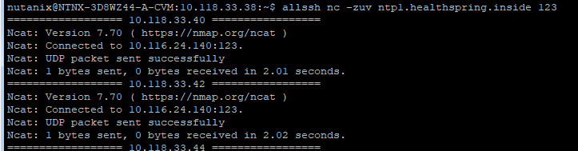

If all CVM nodes succesfully rechable and still giving NTP not rechable issue then. Restart genesis service on all CMM by following command.

nutanix@cvm$ allssh genesis restart

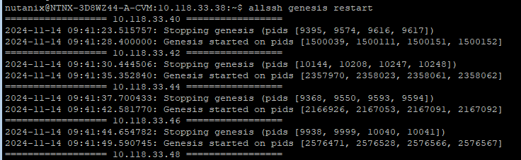

This will restart genesis service on all CVM and elect new NTP leader between them.

Rerun NCC Check.

**Lack of space on CVM Home drive**

1. Log into a CVM
2. Run the following commands to download the cleaning script
3. **cd ~/tmp**
4. **wget -O KB-1540_clean_v12.sh http://download.nutanix.com/kbattachments/1540/KB-1540_clean_v12.sh**
5. **sh KB-1540_clean_v12.sh**
6. **./nutanix_home_clean.py**

* IF Prism Central give followings alerts: **Pod ntnx-system/vsphere-csi-controller-54b889c7d6-d86nk (vsphere-csi-controller) is in waiting state (reason: "CrashLoopBackOff")**.

This alert means prism central not able manage or check vcenter where this PC (Prism Central) deployed in our case it is **ewrvcsmp01.healthspring.inside.**

So, we have created nutanix-user in this vCenter so PC can validate its disk files.so if above alerts shows up mean there is a mismatched in username password provided to PC and actual username password for the vcenter.

Check CSI controller pod is running or cashing by following commnad.

kubectl get pods -A | egrep "NAME|csi"

If its crashing as below screenshot perform following fix.



Check username and password PC using for this process by following command.

kubectl get secrets vsphere-config-secret -n ntnx-system -o jsonpath='{.data.csi-vsphere\.conf}' | base64 –d

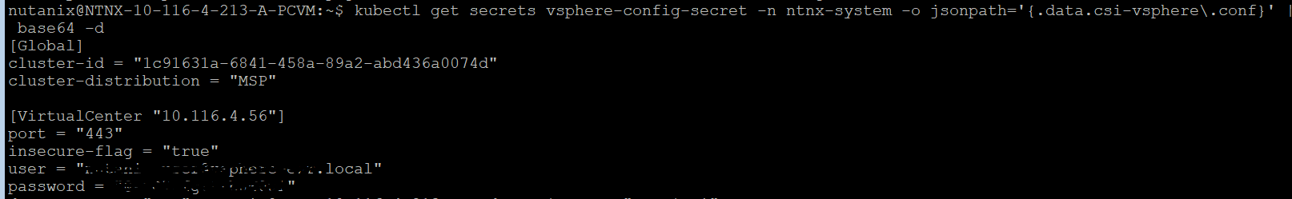

As per above SS you can check vcenter details like url, username and password.

To fix the issue you can create same username password in mentioned vcenter or u can edit this secret file and make necessary changes,

To Edit secrete file:

kubectl edit secrets <secret-name>

For Better understanding you can refer following KB article:

[Update Credentials on vmware-csi driver](https://portal.nutanix.com/page/documents/kbs/details?targetId=kA0VO0000005FWH0A2)